Slug → User friendly URL (fb.com/risal -> here, risal is slug)

Template → wp er any content dekhanr jnno **j php file a** amra code likhi, oigula template

Template part → template k venge soto soto tukra kora hy, segulo template part

Template tag → WP te **content related** php function niye kaj kre template tag

Page template → akta particular page k kono particular php file diye dekhano hoy, oi page gulo k page template bole

Template hierarchy → Template file load howar order

Admin Bar → following red marked portion is admin bar

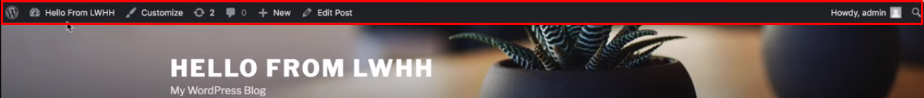

Permalink → **Permanent url**; akta website er url kon structure a dekhano hbe ta e permalink er structure

**Taxonomy**

parent child relationship **thakle**, seita k category type er taxonomy bole

r parent child relationship **na thakle**, ta tag type er taxonomy

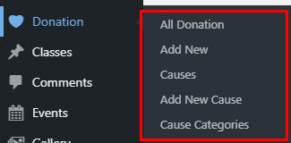

**Terms**

Purata taxonomy, r ‘uncategorized’, ‘new’ eigula ak ak ta term

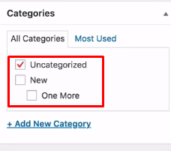

Archive → Collection of any type of post, author or terms is known as archive

Sidebar → shob widget areay, say main sidebar, header, footer sbgula e sidebar

Short code → WP er kono external or internal content k easily show krar jnno akta system

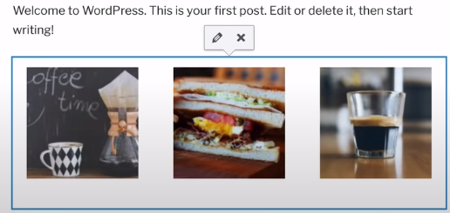



Quick Tag → Text edition a j button gulo thake, segulo quick tag.

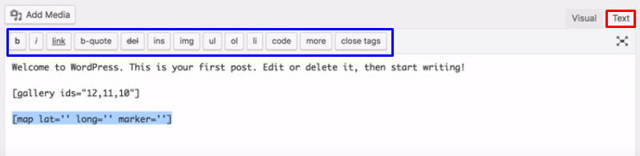

Transient → akta temporary storage, ja memory or database a hoite pare

WP er theme plugin code lekhar smy kisu data temporary store krte hy, segulo **wp er transient api** use kore

